**Table of contents**

**1. Boot to BIOS:** 2

Step 1: Reboot LattePanda 2

1. With Ubuntu 2

2. With Window 3

Step 2: Enter Bios 5

**2. Setting for auto wake-up on power:** 6

Solution 1: For BIOS version 2017 6

Solution 2: For others BIOS 6

**3. Optional - Setting for auto wake-up on LAN network:** 7

Solution 1: For BIOS version 2018 7

Solution 2: For others BIOS 7

**4. Optional - Setting for auto wake-up on exactly time:** 8

Solution 1: For BIOS version 2018 8

Solution 2: For other BIOS 8

# **1. Boot to BIOS:**

#### Step 1: Reboot LattePanda

##### With Ubuntu

To use ***terminal*** to reboot LattePanda, enter the following command:

* sudo systemctl reboot now

*Press Enter*

Or use ***interface*** to reboot LattePanda:

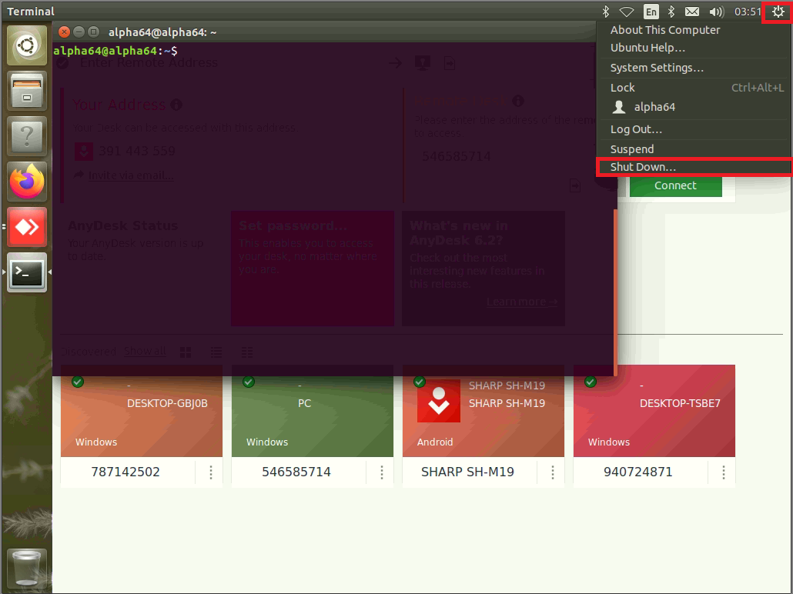

*Go to the top right corner, click on the gear symbol and select shutdown from the drop-down menu*

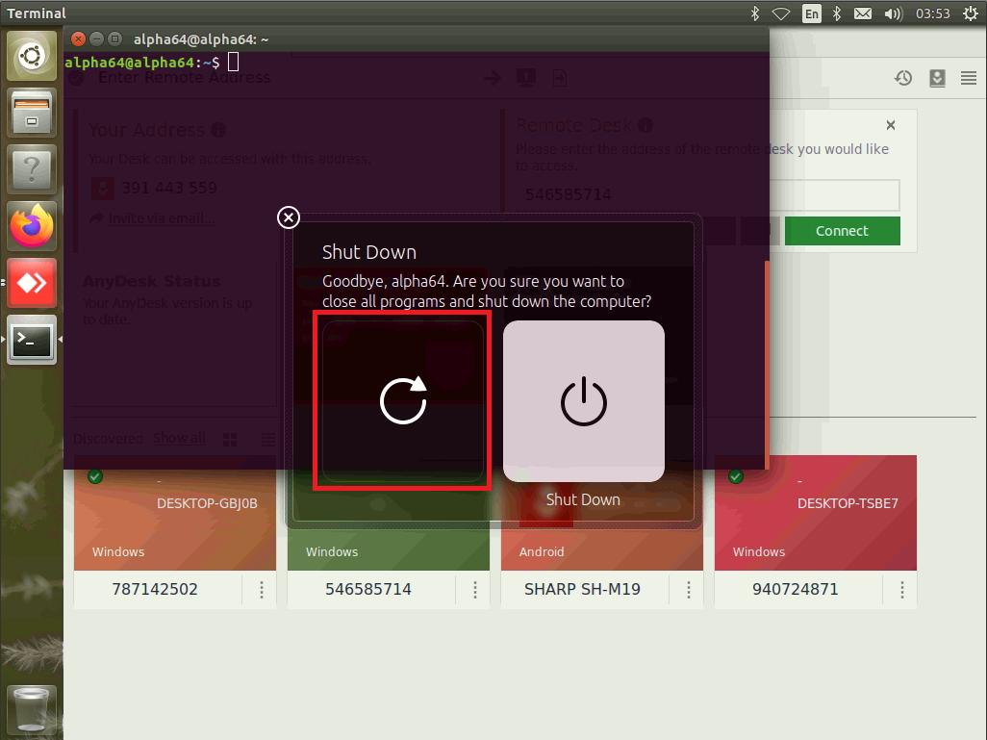

*Choose the left icon*

##### With Window

To use ***command***:

Key combination **Windows logo key + R** to open the **Run** dialog box

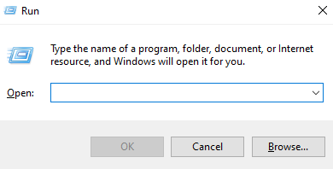

*Success screen*

Enter the following command to reboot LattePanda after 10s:

* shutdown /r /t 10

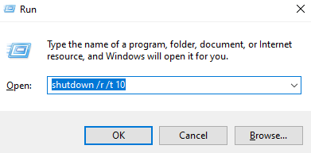

*Press Enter*

**

*Success screen*

Or use ***interface*** to reboot LattePanda:

Click on the microsoft icon on the bottom left screen and follow 3 steps as shown below:

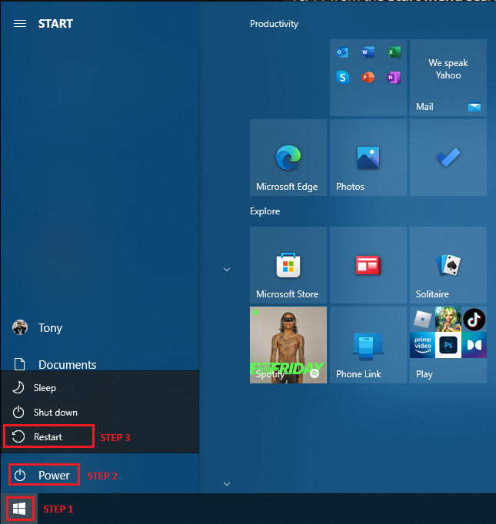

*Do it sequentially from step 1 to 3*



*Success screen*

#### Step 2: Enter Bios

Press ‘**DEL**’ key continuously to enter into BIOS menu before you see the LattePanda logo on the splash screen

*Success screen*

# **2. Setting for auto wake-up on power:**

Depending on the bios version that LattePanda uses, there are various solutions to this issue. Try each one till you find the suitable solution:

#### Solution 1: For BIOS version 2017

*Source:* [*https://m.blog.naver.com/PostView.naver?isHttpsRedirect=true&blogId=pknujjang&logNo=220976659177*](https://m.blog.naver.com/PostView.naver?isHttpsRedirect=true&blogId=pknujjang&logNo=220976659177)

***Path: BIOS Setup → Boot → Machine Status AC/Battery In***

From the part 1 success screen:

* Go into Boot → Machine Status AC/Battery In
* Change it to **Power On**

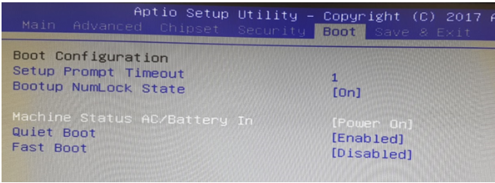

*Success Screen*

#### Solution 2: For others BIOS

*Source:* [*http://docs.lattepanda.com/content/3rd_delta_edition/bios/*](http://docs.lattepanda.com/content/3rd_delta_edition/bios/)

***Path: BIOS Setup -> Advanced -> Power Management -> AcPowerLoss***

From the part 1 success screen:

* Go into Advanced → AcPowerLoss
* Change it to **Power On**

*Success Screen*

# **3. Optional - Setting for auto wake-up on LAN network:**

Depending on the bios version that LattePanda uses, there are various solutions to this issue. Try each one till you find the suitable solution:

#### Solution 1: For BIOS version 2018

***Path: BIOS Setup → Advanced → Wake on Lan***

From the part 1 success screen:

* Go into Advanced → Wake on Lan
* Change it to **Enable**

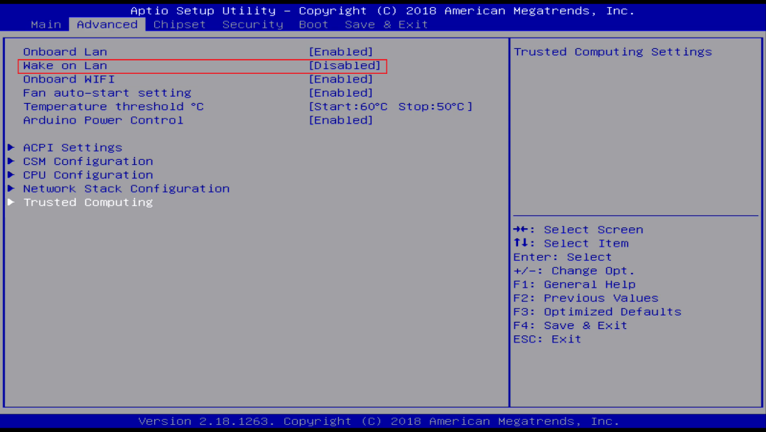

*Change from* ***Disable*** *to* ***Enable*** *by press* ***Enter***

#### Solution 2: For others BIOS

***Path: BIOS Setup → Advanced → Wake on Lan***

From the part 1 success screen:

* Go into Advanced → Wake from Lan
* Change it to **Enable**

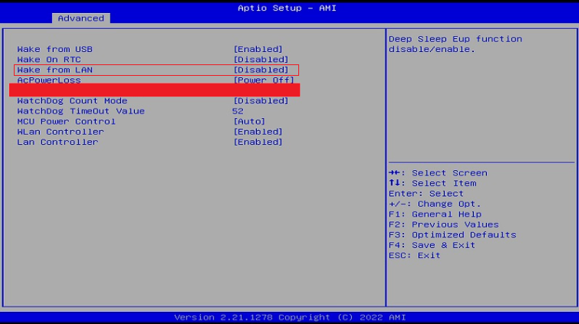

*Change from* ***Disable*** *to* ***Enable*** *by press* ***Enter***

# **4. Optional - Setting for auto wake-up on exactly time:**

Depending on the bios version that LattePanda uses, there are various solutions to this issue. Try each one till you find the suitable solution:

#### Solution 1: For BIOS version 2018

***Path: BIOS Setup → Chipset → Wake system from S5***

From the part 1 success screen:

* Go into Chipset → Wake system from S5

Change it to **Enable** and set exactly time:

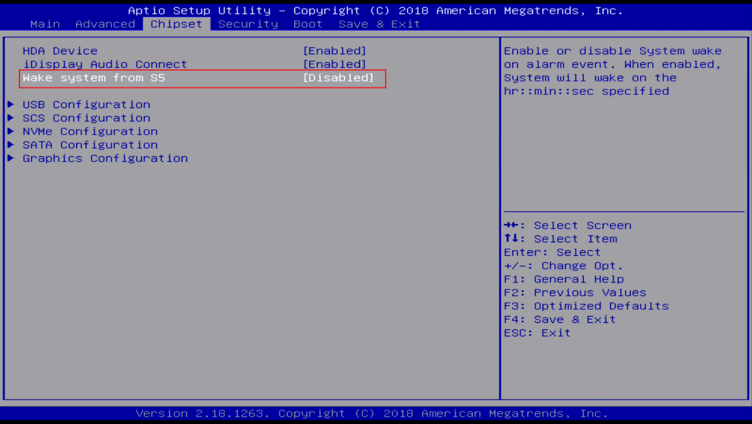

*Change from* ***Disable*** *to* ***Enable*** *and set time to auto power on*

#### Solution 2: For other BIOS

***Path: BIOS Setup → Advanced → Wake on RTC***

From the part 1 success screen:

* Go into Advanced → Wake On RTC

Change it to **Enable** and set exactly time:

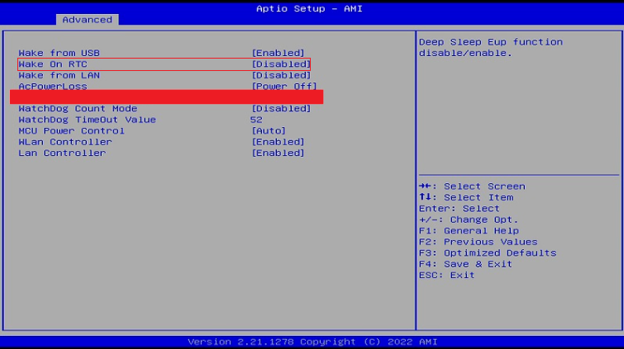

*Change from* ***Disable*** *to* ***Enable*** *and set time to auto power on*